**Unit 3 Information systems**

**P6 Select information to support a business decision-making process**

**Help sheet**

To meet P6, you need to search for and find a large dataset from the Internet, which contains some statistical information, which may prove useful to Sally Chester at the Hotel.

An example is provided for you below.

[**www.ons.gov.uk**](http://www.ons.gov.uk)

**Click on Data tab**

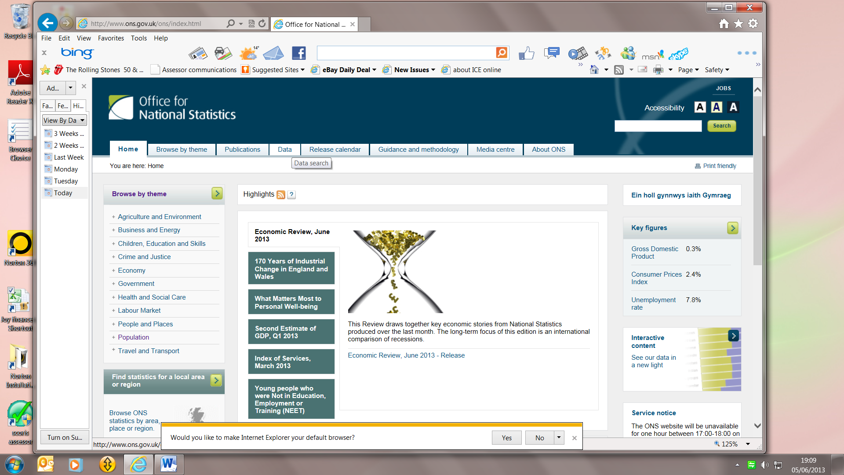

Then you can search for Tourism trends.

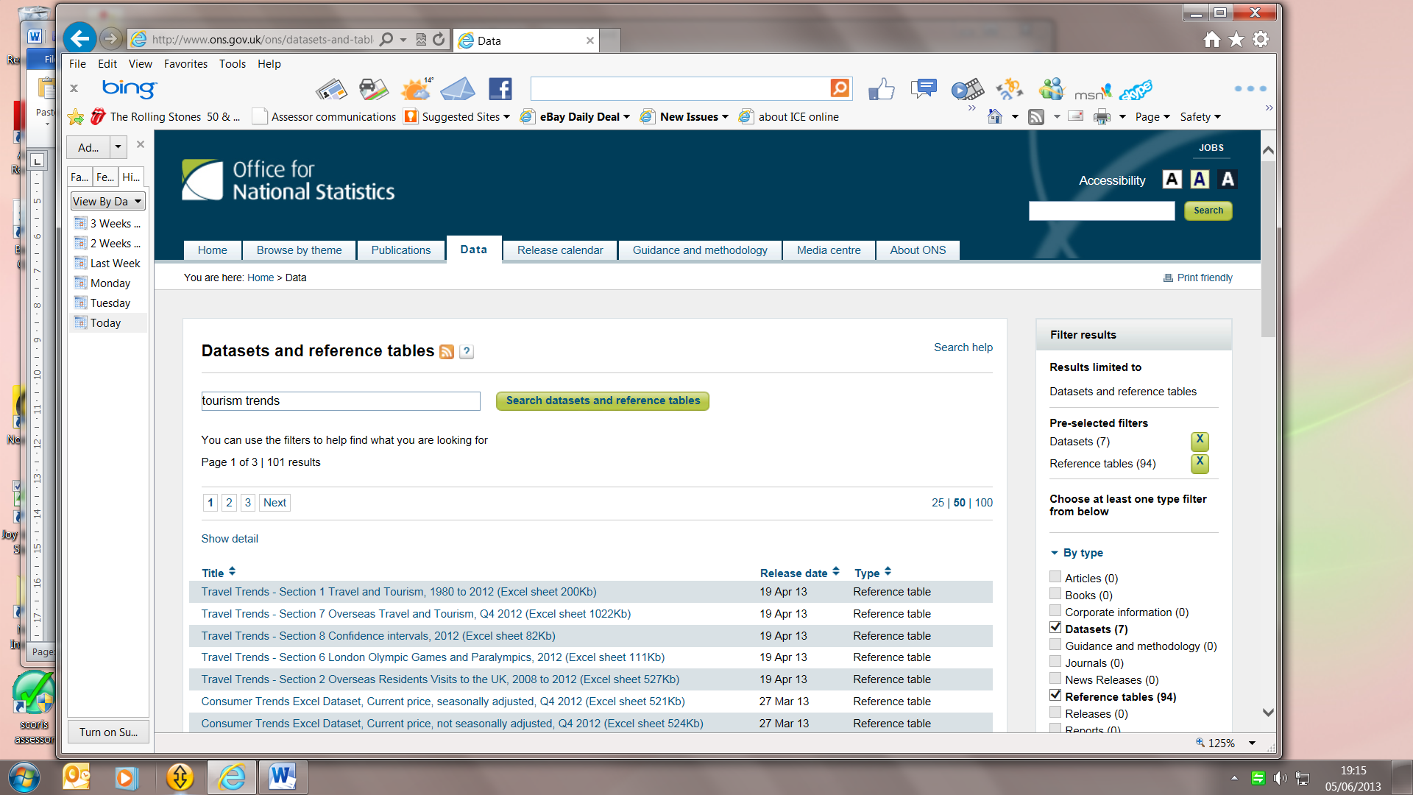

As an example, I clicked on **Travel Trends Section 1 Travel and Tourism 1980 to 2012 (Excel sheet) and saved it. See below.**

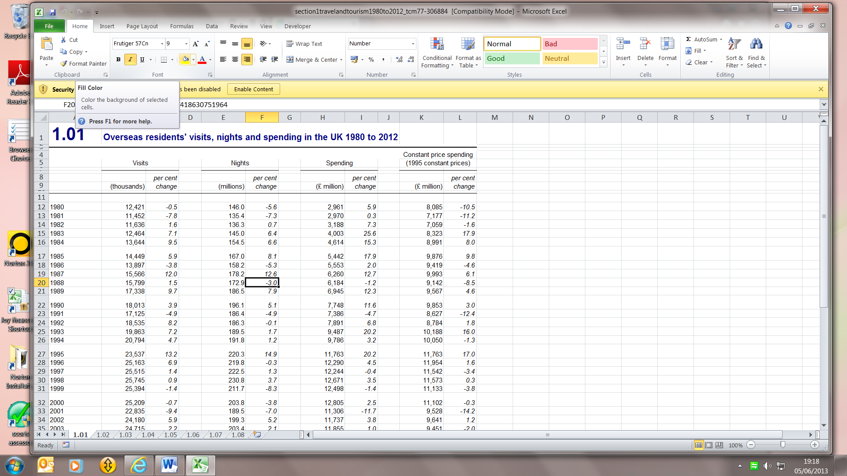

Analysing this data could be useful to Sally Chester at the hotel so that she can find out whether or not the number of overseas visitors is increasing. She could therefore plan events which may be of interest to overseas visitors, or provide some language training for the staff to help them communicate more effectively with these visitors.

Here is another example.

**Spending on meals out**

